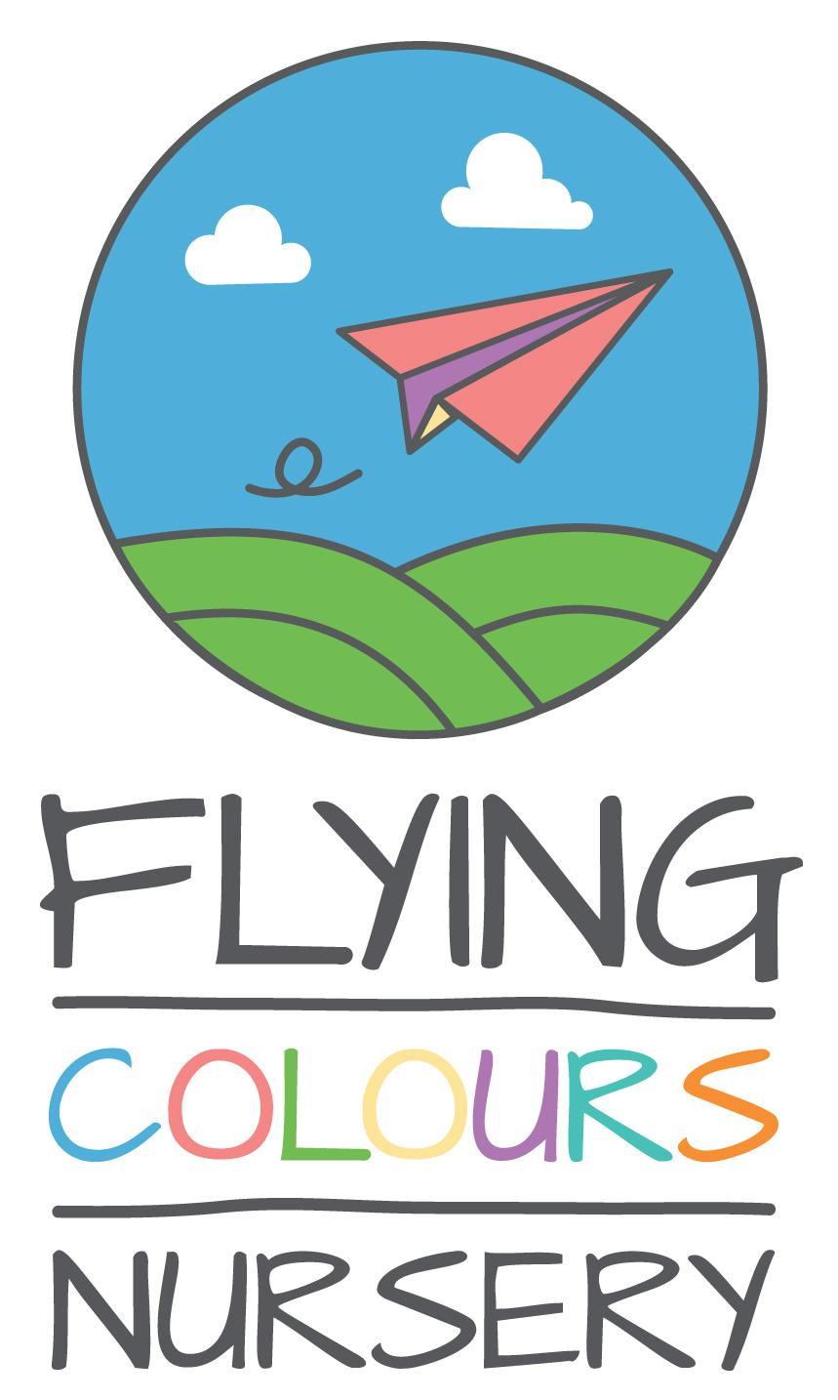

GUIDANCE NOTES FOR COMPLETING YOUR APPLICATION FORM
Please read carefully before completing your application form
- A nursery can receives many applications for each post advertised. It is our intention to appoint the best candidate for every vacancy in accordance with our Equal Opportunities Policy. To do this fairly, we need all applicants to provide relevant information about themselves. This should be based on the criteria listed on the job description, which are regarded as essential or desirable to the job.

- Your application should provide us with as much relevant information as possible. It is the quality of the information and the presentation of your application that will help the selection panel to decide whether to interview you or not.

- Section 3 of the form asks about education and qualifications. We do not need a full account of your education here but please mention qualifications and/or training which are necessary or relevant to the job for which you are applying.

- Section 6 should be used to tell us how you think you meet each of the selection criteria listed on the job description. Draw particular attention to experience, skills, achievements and knowledge gained in past employment or other activities relevant to job. It would be helpful if you used headings for each criterion listed and demonstrate how you feel you meet each requirement.

- Where possible, please ensure at least one reference is from your current employers. Please always Include an email address and phone number for references, we will always ask you permission before contacting anyone.
A few other do's and don'ts to assist you in the completion of the application form
DO:
- State which position you are applying for.
- Complete the form with a word processor (e.g. MS Word).
- Ensure that all parts of the form are completed and are clear.
- Use extra pages where necessary.
- Address each individual requirement of the person specification.
DO NOT:
- Send in a CV with or in place of your application.
- Send your application after the closing date - late applications might not be accepted.

NB. The Equal Opportunities Monitoring Form is not part of the selection process and will be removed prior to shortlisting.

0. POSITION

Are you applying for a specific position:
If yes, what position:

1. PERSONAL DETAILS

Surname:
First Name:

Address:

Telephone Number :
Mobile Number:
Email:

2. REFERENCE 1

References Name:
Employer:
Job Title:
Address:

Telephone:
Relationship:
Email:
Can references be contacted?: Yes/No

2. REFERENCE 2

References Name:
Employer:
Job Title:
Address:

Telephone:
Relationship:
Email:
Can references be contacted?: Yes/No

3. QUALIFICATIONS & TRAINING

Starting with the most recent, please give details of your education, qualifications and training relevant to the application. Details of education/training, school, college or organisation, qualifications obtained and training relevant to the application.

4. EMPLOYMENT HISTORY

Starting with your present or most recent job, please give a summary of all employment, including any freelance and relevant unpaid work. Name of your employer and nature of business, job title, brief details of your responsibilities, salary and benefits.

5. CURRENT OR MOST RECENT EMPLOYMENT

Please describe your job responsibilities fully, and list your main achievements.

6. PERSON SPECIFICATION

Please describe how your background experience, skills and attributes meet the requirements set out in our Person Specification.

7. OTHER RELATED INFORMATION

Please explain your reasons for making this application and add any further information about yourself that you consider may be relevant.

8. DECLARATION

I confirm that the information supplied by me in this application is correct. I agree that any offer of employment will be subject to satisfactory references, and I may be required to supply medical information.

Full Name Date

Please return this form and the equal opportunities monitoring form to the nursery by email to: barnton@flyingcoloursnursery.co.uk
Alternatively, please send by post to: 534 Queensferry Rd, Edinburgh, Midlothian EH4 6EE

